Kerin Quintero

Ctech 450

Dr. Jackson

2/25/25

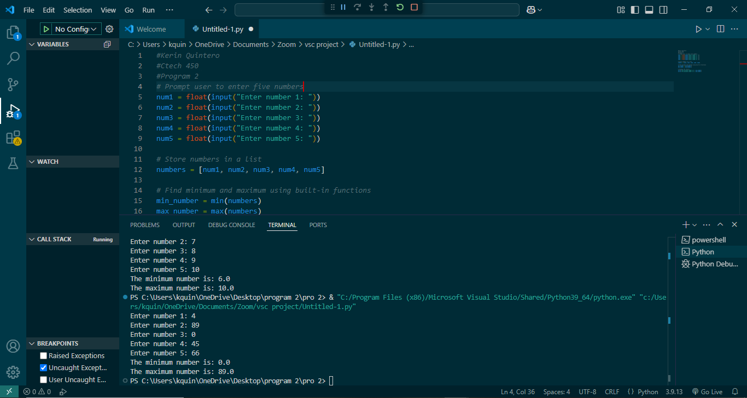

This program asks the user to enter five numbers and then finds the smallest and largest numbers. It stores the numbers in a list and uses Python's built-in min() and max() functions to find the lowest and highest values. After that, it prints the results. For example, if the user enters **4, 89, 0, 45, and 66**, the program will say that **0 is the smallest** and **89 is the largest**. This makes it easy to quickly find the minimum and maximum numbers.